**Financing rare diseases**

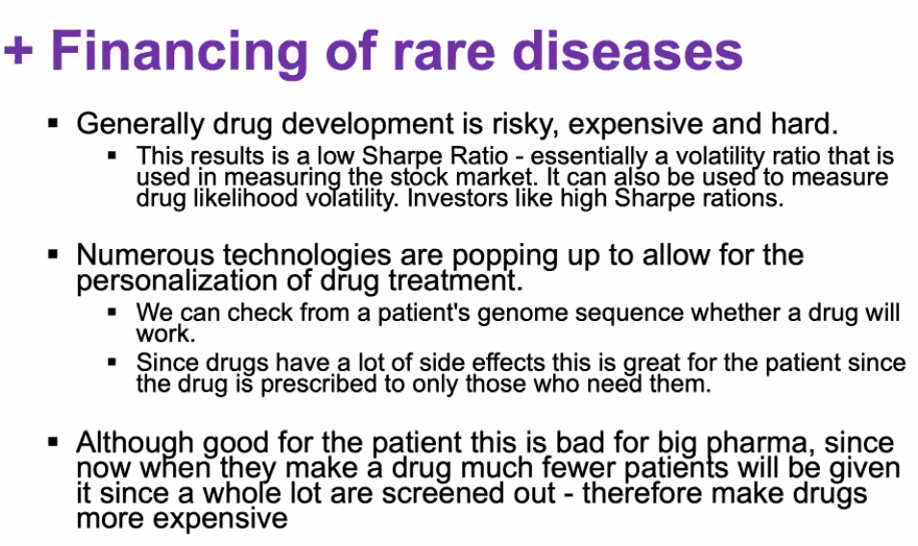

Sharpe Ratio = ((return of portfolio) – (risk-free rate)) / (standard deviation of portfolios excess return)

-can’t just do one drug at a time-very expensive-so produce a portfolio

**Diagnosing depression**

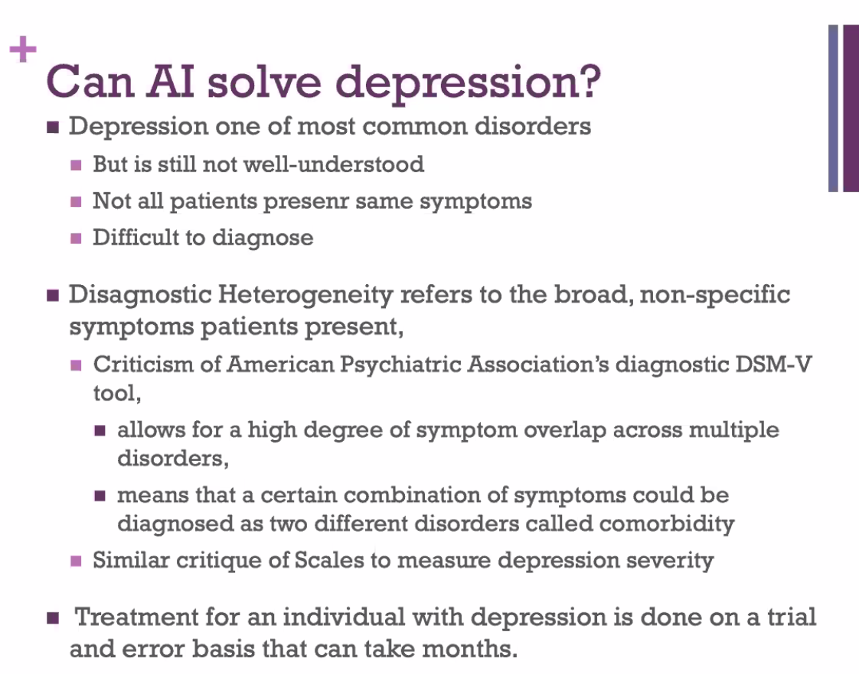

-claims of subtypes of depression based

Neuro imaging not popular-might not be brain structure, but rather processes, like serotonin levels or hormone interactions

Many studies have too few patients

